Novel Materials Constructed from Chitin and Chitosan

Lina Zhang, Bo Duan, Kunkun Zhu, Jainjain Duan, Chunyu Chang, Ang Lu, Jie Cai
College of Chemistry and Molecular Sciences, Wuhan University, Wuhan 430072, China
Email: zhangln@whu.edu.cn

Faced with the serious challenge of “Environmental Protection and Sustainable Development”, we have developed a new route to fabricate novel materials derived from chitin and chitosan by using “green” low-cost chemical reagents (alkali/urea aqueous solvents) via environmentally friendly process. From the chitin and chitosan solutions in the alkali/urea aqueous system, the regenerated chitin/chitosan materials including fibers, films, microspheres, plastics, hydrogels and aerogels have been fabricated (Fig 1). Interestingly, these materials constructed directly from the chitin or chitosan solutions, exhibited excellent mechanical properties, sensitively force-response, magnetic-induced delivery, the good electrochemistry properties & high discharge capacity, as well as the excellent biocompatibility, the cells adhesion and proliferation viability. They are believed to have promising applications in biomedical materials, energy storage, catalyst supports and wastewater treatments. More importantly, these chitin/chitosan-based materials are biodegradable in the earth/river that will lead to the implementation of a (future) sustainable society. Therefore, we opened a completely new avenue to construct novel materials from the natural polymers via a “green” process, leading to the promising wide applications.
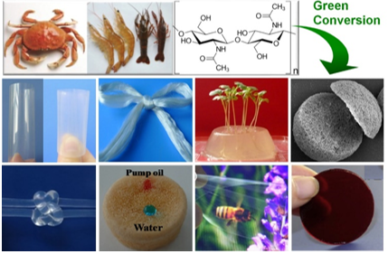

Figure 1 Photographs of chitin derived from the seafood wastes such as waste crab, shrimp and lobster shells, and the construction of novel materials via physical approaches and green technology

